Physics 30H Lesson 3H Energy and Momentum

I Elastic collisions

Recall that there are four basic types of questions that require a solution involving momentum: elastic collisions, partly elastic collisions, inelastic collisions and recoil/explosion. In addition, recall that kinetic energy is conserved in elastic collisions only. For the other types, kinetic energy is not conserved. The conservation of both kinetic energy and momentum provides a powerful tool for solving some problems.

Example 1

Ball A (mass = 5.0 kg) is traveling to the right at 10 m/s and elastically collides with a stationary ball B (mass = 4.0 kg). What are the velocities of the balls after the collision?

There are two unknowns: v_{A}’and v_{B}’ Since the collision is elastic, both momentum and kinetic energy are conserved. Applying this observation we have two equations and two unknowns.
Σp_{before} = Σp_{after}
m_{A}v_{A} = m_{A}v_{A}’ + m_{B}v_{B}’
5.0 kg(10 m/s) = 5.0 kg v_{A}’ + 4.0 kg v_{B}’
50 = 5.0 v_{A}’ + 4.0 v_{B}’ (1)

ΣE_{k before} = ΣE_{k} _{after}
½ m_{A}v_{A}² = ½ m_{A}v_{A}^{2’} + ½ m_{B}v_{B}^{’2}
5.0 kg(10 m/s)² = 5.0 kg v_{A}^{2’} + 4.0 kg v_{B}^{’2}
500 = 5.0 v_{A}^{2’} + 4.0 v_{B}^{’2} (2)

With a system of two equations and two unknowns we can solve for both velocities.

Rearranging equation (1) we have:
v_{A}’ = 50 - 4.0 v_{B}’ (1)
5.0
Substitute (1) into (2)
500 = 5.0 v_{A}^{’2} + 4.0 v_{B}^{’2} (2)

500 = 5.0 (50 - 4.0 v_{B}’) ² + 4.0 v_{B}’²
5.0²
500 = (2500 - 400 v_{B}’ + 16 v_{B}’² ) + 4.0 v_{B}’²
5.0
2500 = 2500 - 400 v_{B}’ + 16 v_{B}’² + 20 v_{B}’²
0 = - 400 v_{B}’ + 36 v_{B}’²
0 = - 400 + 36 v_{B}’
v_{B}’ = +11.1 m/s or 11.1 m/s to the right

Substitute v_{B}’ = +11.1 m/s back into (1)
50 = 5.0 v_{A}’ + 4.0 v_{B}’ (1)
50 = 5.0 v_{A}’ + 4.0 (11.1 m/s)
v_{A}’ = +1.1 m/s or 1.1 m/s to the right

II Practice Problems

1. Ball A (mass = 4.0 kg) is traveling to the right at 10 m/s and part elastically collides with a stationary ball B (mass = 5.0 kg). If 10% of the initial kinetic energy is converted into heat, what are the velocities of the balls after the collision?
(-0.59 m/s, +8.47 m/s)

III Hand-in Assignment
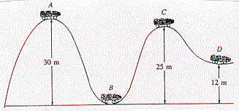
1. The roller coaster in the drawing passes point A with a speed of 1.20 m/s. If the average force of friction is equal to one-fifth of its weight, with what speed will it reach point B? The distance traveled is 67.0 m. (18.1 m/s)

2. A 3.00 kg model rocket is launched vertically straight up with sufficient initial speed to reach a height of 1.00 x 10² m, even though air resistance performs
-8.00 x 10² J of work on the rocket. How high would the rocket have gone without air resistance? (127 m)
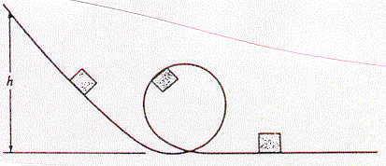

3. A small mass m slides without friction along the looped apparatus shown in the drawing. If the object is to remain on the track (whose radius is r), from what minimum height h must it be released? (5/2 r)

4. A grappling hook, attached to a 1.5 m rope, is whirled in a circle that lies in a vertical plane. The hook is whirled at a constant rate of three revolutions per second. In the absence of air resistance, to what maximum height can the hook be cast? (42 m)

5. A 2.0 m long pendulum is pulled to an angle of 40 from the vertical. What is the pendulum’s maximum swing height and speed?
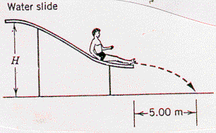

6. A water slide is constructed so that swimmers, starting from rest at the top of the slide, leave the end of the slide traveling horizontally. As the drawing shows, one person is observed to hit the water 5.00 m from the end of the slide in 0.500 s after leaving the slide. Ignoring air resistance and friction, find the height in the drawing. (6.32 m)

7. A 2.5 kg bomb explodes into two fragments with masses of 1.0 kg and 1.5 kg. The chemical explosive contained 5.0 kJ of potential energy. If 70% of the chemical energy is lost as heat, what are the velocities of the bomb fragments?
(-28.3 m/s, +42.4 m/s)

8. Two identical steel balls are traveling toward each other with velocities of - 4.0 m/s and +7.0 m/s, and they experience an elastic head-on collision. Obtain the velocities (magnitude and direction) of each ball after the collision. (+7.0, -4.0 m/s)

9. A skate boarder of mass 65.0 kg wearing the newly developed frictionless body suit on a brand new 2.0 kg polymekelyte board with the revolutionary frictionless cyberwheels leaves position A. The whole plan is to take a the short cruise down the vertical incline and then across the horizontal plane to grab and ride the 12.0 kg tire suspended from a crane by a fine light rope at position B. Just as the skateboarder reaches the highest point above the horizontal plane at position C, the rope snaps resulting in the skateboarder and tire falling together. What momentum will the tire and skate boarder have when they collide with the surface of the water below? (1.07 x 10³ kg m/s)

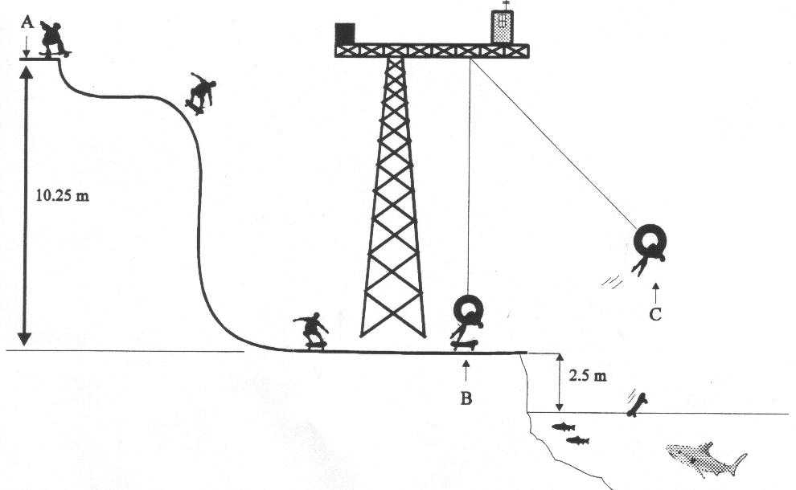

Challenge questions (These are not for the faint of heart!!)

10. A swing is made from a rope that will tolerate a maximum tension of 8.00 x 10² N without breaking. Initially, the swing hangs vertically. The swing is then pulled back at an angle of 60.0 with respect to the vertical and released from rest. What is the mass of the heaviest person who can ride the swing? (40.8 kg)

11. A proton traveling with a speed of 8.2 x 10⁵ m/s collides perfectly elastically with a stationary proton. One of the protons is observed to be scattered at a 60º angle. At what angle will the second proton be observed and what will be the velocities of the two protons after the collision? (30º, 4.1 x 10⁵ m/s, 7.1 x 10⁵ m/s)

